INTERNAL MOCK EXAMINATIONS – 2018
Uganda Advanced Certificate of Education
BIOLOGY P530/2
MARKING GUIDE

  - (a) (i)

Sample | Number of fruit flies in a sample | Cumulative samples size
1 | 150 | 150
2 | 90 | 240
3 | 55 | 295
4 | 30 | 325
5 | 24 | 349

(ii) Graph showing the relationship between number of fruit flies captured per sample and the previous cumulative number of flies .
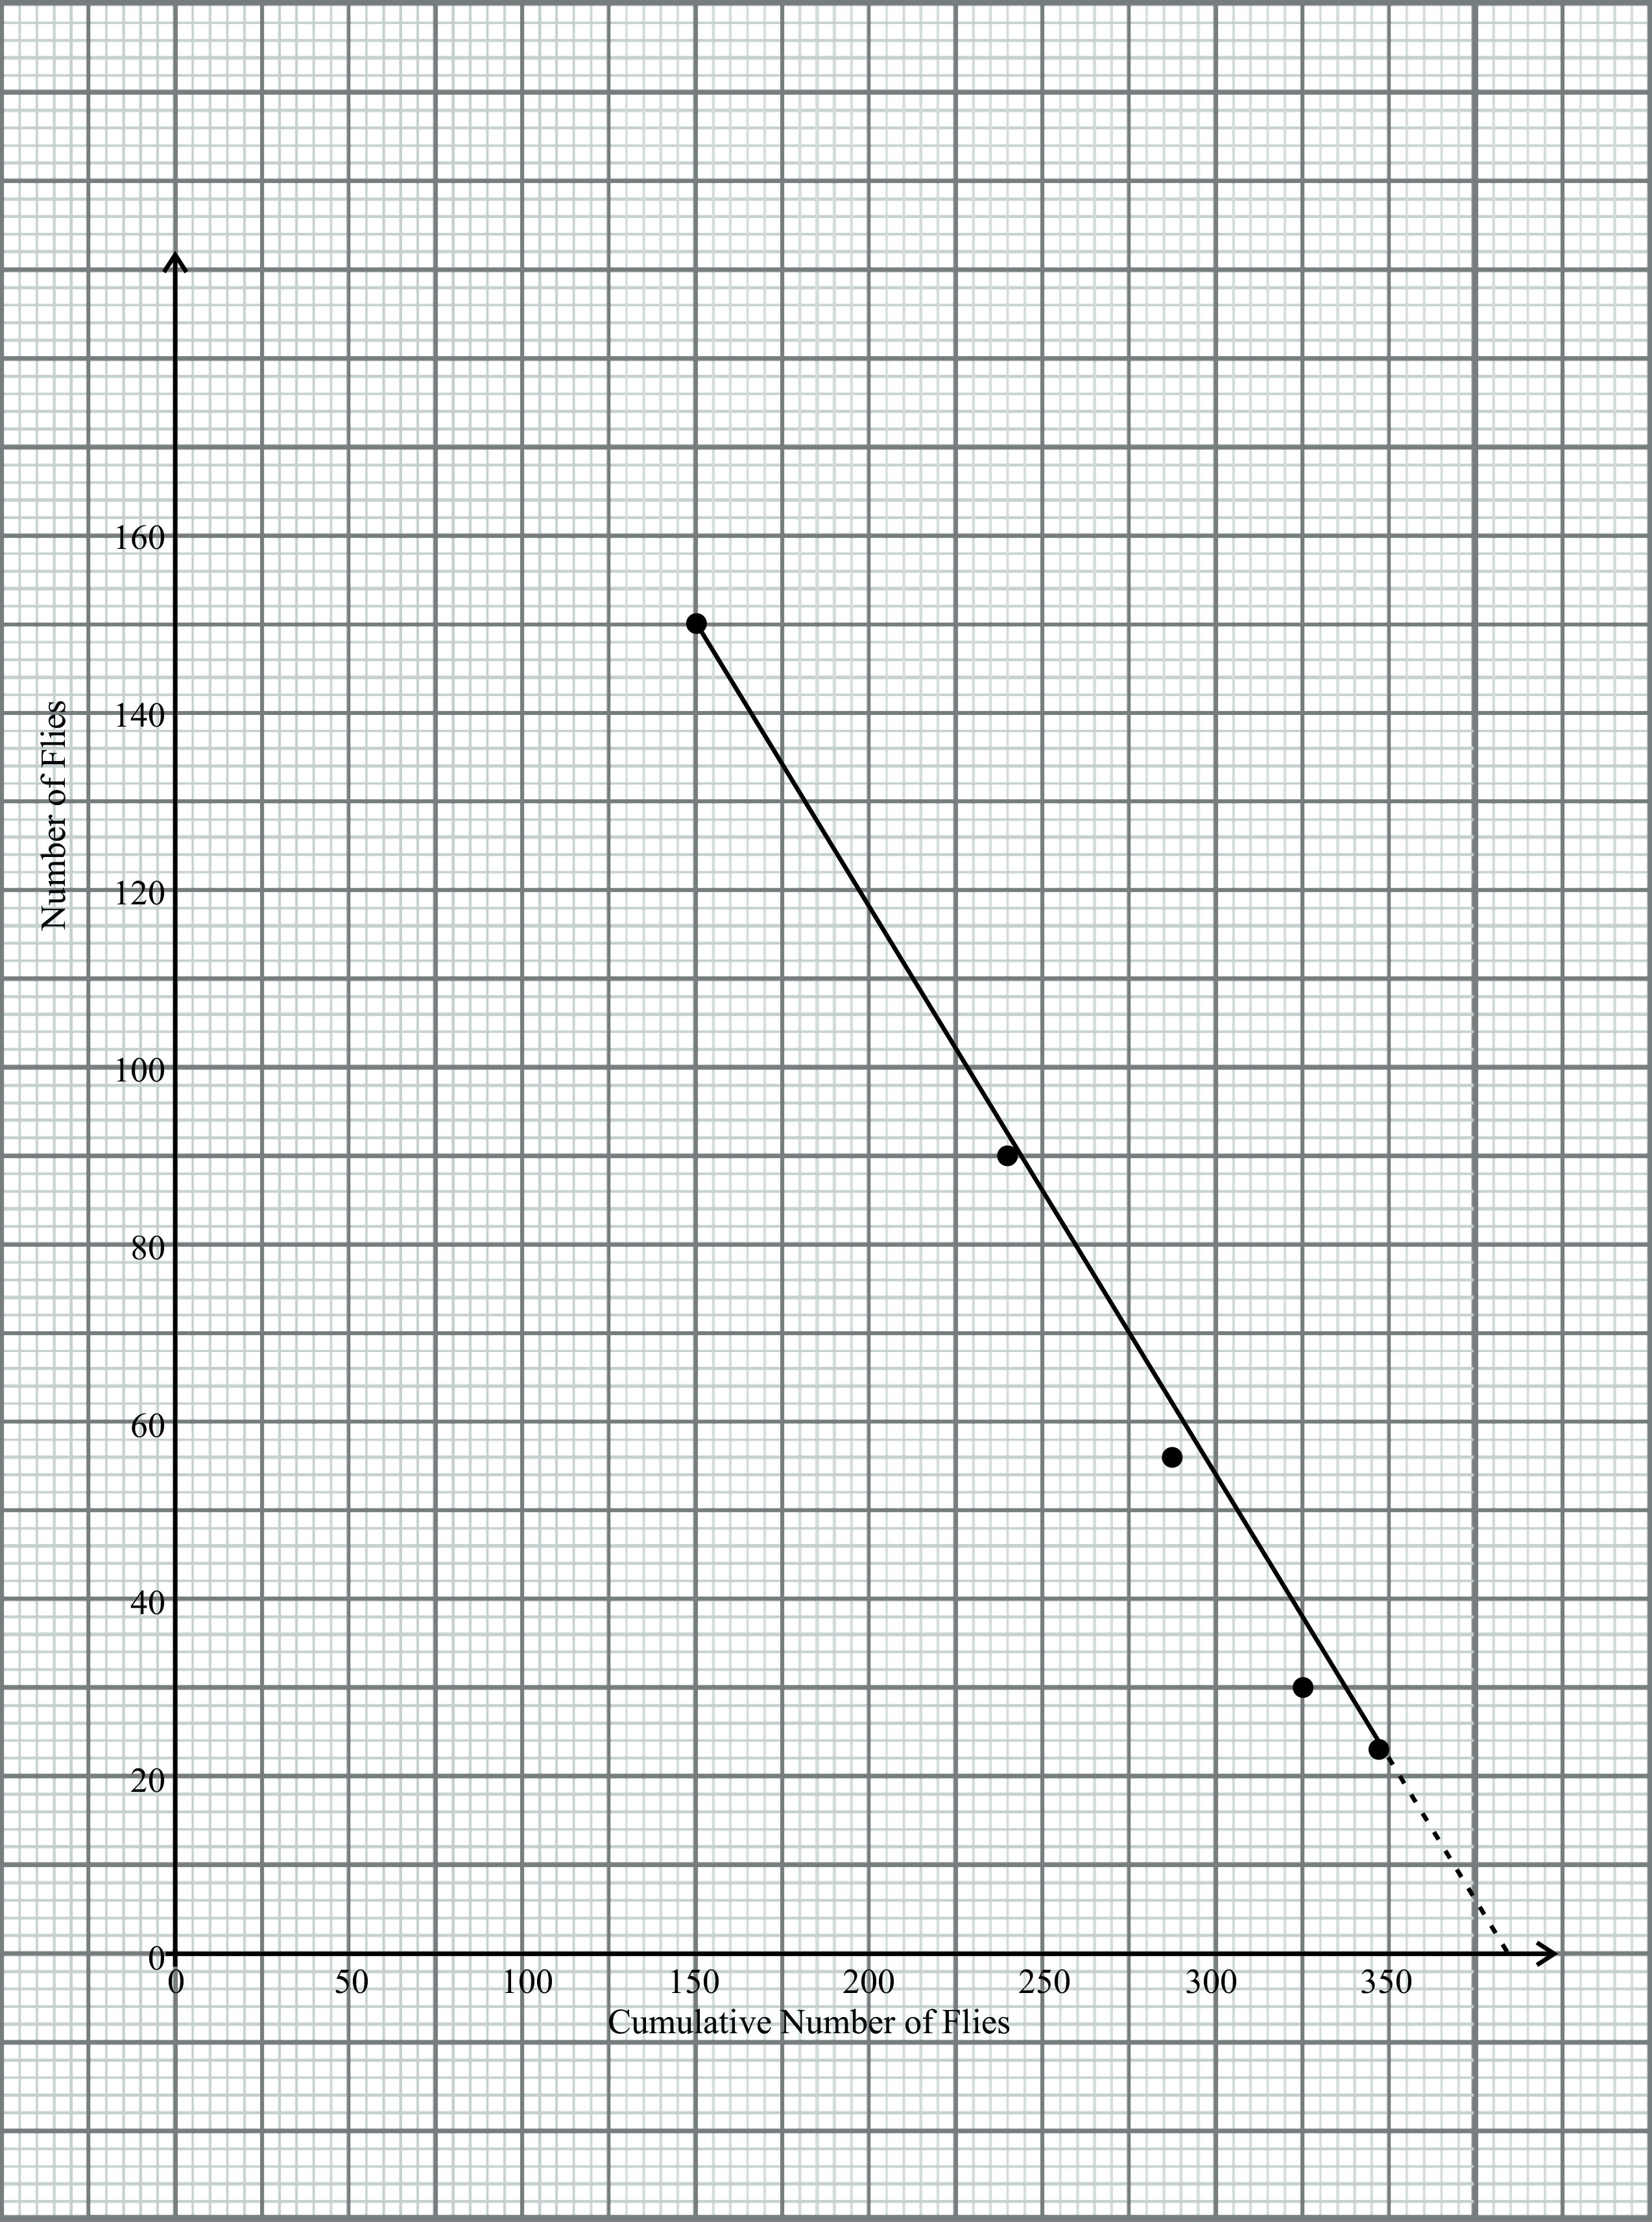
Vertical scale:
1cm represents 10 flies
Horizontal scale:
1cm represents 25 cumulative number of flies.
T – 01, Sc – 01, DA – 01,
LA – 01, Pts – 2½ , Ext – ½.

(b) (i) 380 files – 370 flies
acc 385 flies
- ii. Graph was extrapolated, to touch x-axis (02 marks)
- the intercept value indicates the total population of flies
- The number in the sample at accumulative sample size is zero implying that all the flies were captured and hence no flies were there in the environment;

(c) (i) Removal method (01 mark)
(ii) Capture-recapture method (Lincoln Index)
The files are small fast moving and often concentrated in one area.

(d) (i) Exposing a plant to short day illumination cycle inhibits flowering
because it results into the re-conversion of the accumulated pr to inactive pr during long hours of darkness which inhibits the production of/release of a hormone florigen from its precursors hence inhibiting flowing;
A brief flash of light in the middle of the dark period for several day induces flowering due to rapid conversion of pr to the inactive pfr since the dark period is shortened accumulated pfr stimulates the release of hormone florigen transported via the phloem to flower buds at the apex to induce flowering.

(ii) The percentage germination of long day illuminated seed sample is
higher because pr in cotyledons and coleoptiles of seeds absorb red light and converted to active pfr which stimulates secretion of gibberellins from embryo which initiates the synthesis of hydrolytic enzymes which catalyze the breakdown of stored food to soluble products that are Trans located to the growing regions of embryo (radical and plumule).
Percentage germination of short day illuminated seed sample is lower because the remaining low levels of pfr to pr during a long dark period initiates secretion of low levels of gibberellins.

  - (a) Released from sarcoplasmic reticulum into sarcoplasm Ca²⁺ bind to
Troponin to form Ca²⁺⁻ troponin complex the complex displaces tropomysin which has been blocking the myosin head binding site on action. (07 marks)
(b) Muscles fatigue which continued contraction called tetanus, gradually
declines and muscle relaxes even when the stimulus is significantly strong,
due to:-
    - Depletion of stored energy for contracting

Accept – Exhaustion of transmitter substance due to repeated stimulation of a
muscle.
    - Accumulation of carbondioxide from sustained respiration; which lowers the PH and offsets enzymes functioning.
    - Muscles may respire an aerobically due to insufficient oxygen leading to accumulation of lactic acid which affects enzymes such as AT pase.

(c) Compact bone consists of a matrix comprising of collagen fibres together
with inorganic substances such as calcium, phosphorous and magnesium salts the matrix is called osteon.
The components in it are arranged in concentric circles called lamellae around a central canal called haversiun lymph vessels and nerve fibres. Numerous lacunae are found in between lamellae which contain bone cells osteoblasts connected to haversian canal by canaliculi capillaries branch from the arteries and veins in the havesian canal, pass via canaliculi to lacunae the outer layer is covered by a dense connective tissue called periosteum.

  - (a) (i) Allopatric speciation is where a single species of organisms give rise to
new species as a result of their population being isolated/separated by physical or geographical barriers hence it occurs when organisms are occupying different areas where organisms in each population evolve along their own line. (03 marks)

(ii) Sympatric speciation is where a single species without their
population being isolated by geographical barriers and it occurs when the population of organisms is occupying the same area as a result of merging of two populations which were previously isolated.
OR
- Allopatric speciation is the formation of new species when populations are separated by geographical barriers/isolated demes diverge/evolve as they accumulate genetic differences ultimately preventing successful mating between the demes thus new species. (03 marks)
- Sympatric speciation is the formation of new species from a population in the same geographical area due to niche differentiation and subsequent reproduction isolation. (03 marks)

(b) In a heterogenenous environment populations exist within a diverse
collection of microhabitats some organisms may prefer one microhabitat mostly and rarely come in contact with others, others are so dependant on a particular microhabitat that they never meet others in other habitats this genetically isolates them for so long that they become reproductively isolated i.e. no gene flow thus development of new species. (09 marks)

(c) Respiration releases energy needed to bind Ca²⁺ to troponin to form Ca²⁺
troponin complex.
Polyploidy is a condition arising during meiosis where an organism
acquires extra complete sets of chromosomes such that the daughter cells have multiples of chromosomes e.g. giving rise to tetraploids and triploids.
Polyploidy produces sudden reproductive isolation of organisms disturbs sex determination mechanisms in animals/interferences with normal gamete formation due to odd numbers of chromosomes thus sterile animals and no new species.
Polyploidy in plants, vegetative reproduction is possible inplants instead of self pollination (ability to reproduce on their own) enabling polyploidy plants to produce a breeding populations.

4. (a)
Photorespiration | Respiration
Occurs in presence of light | Light independent
3 organelles are involved ie chloroplasts, peroxisomes and metochondria | Single organelle involved by occurs in cytoplasm and metachondria
Wasteful loss of ATP | Release of ATP
Mainly in C₃ plants | In plants and animals
Decreases yield in C₃ plants | Essential for both plants and animals

(b) Carbondioxide from the atmosphere diffuses into the leaf cells through stomata and finally reaches the stroma of chloroplasts of palisade cells it combines with/accepted by a 3C compound phosphoenol pyruvate (PEP) in presence/by help of enzymes PEP carboxylase to form a 4C compound called Oxaloacetate (OAA) the first stable product OAA is then reduced by NADPH₂ to malic acid (malite) which is shunted to bundle sheath cells through plasmodesmata where it is decarboxylated to pyruvic acid releasing carbondioxide pyrvic acid returns to palisade cells and used to synthesize more PEP C0₂ in the bundle sheath cells is accepted by ribulose biphosphate (RuBp) a 5C compound which splits immediately to two molecules of 3C atoms called phosphoglyceric acid (PGA)/glycerate -2- phosphate (GP) which is reduced by NADPH2 and A+p to phosphoglyceraldehyde (PGAL)/triose phosphate (TP) two molecules of TP combine to form a hexose sugar some TP used to regenerate RUBP. (14 marks)

(c) In C₄ plants, carbondioxide fixation occurs at a higher rate since PEP
carboxylase is more efficient.
- C₄ plants accumulate C0₂ internally in the bundle sheath cells which increases the rate of carbondioxide fixation hence photosynthesis.
- Photorespiration does not occur in C₄ plants unlike in C₃ plants at a higher 0₂ concentration.
- RUBP carboxylase/oxgyenase works best innC4 plants due to high C0₂ concentration.
- Light saturation in C₄ plants takes place at a much higher light intensity than in C₃ plants.
- C₄ plants are more tolerant to diverse conditions of temperature than C₃ plants.
- C₄ plants have higher yields of photosynthetic products since no photo respiration.

5. (i) Mass flow/pressure flow
Is the passive movements of materials through the vascular system/phloem as a result of turg or pressure gradients being highest in leaves (source) and lowest at the sink (storage organs) sugars are actively loaded in the leaf’s sieve tubes which lowers their water potential resulting to osmotic flow of water into them from xylem in the roots sugars are utilized or converted to starch for storage increasing the water potential and water moves out of them to xylem by osmosis this causes a turgor pressure gradient resulting into liquid food to flow from leaves (source) to the sink. (08 marks)

(ii) Cytoplasmic streaming: contraction of cytoplasmic stands that span
from one sieve tube to another creating a wave like motion which moves sugars and amino acids across the sieve plate up and town ward. (04 marks)
- Electro osmosis polar water molecules are swept along with ions through sieve pores which is charged by potential difference.
(02 marks)

(iv) Surface spreading: Soluble products of photosynthesis spread over the
surface between two adjacent cytoplasmic materials continuously as one is added on one side are removed from another. (02 marks)

(b) Mass flow does not explain the bi directional movement of sugars and
amino acids.
- Mass flow does not explain how soluble materials would move if the turgor pressure gradient is insufficient.
- Cytoplasmic streaming occurs only in immature sieve tube cells since it is active process.
- Cytoplasmic streaming is not fast enough to account for the observed rate of phloem transport.
- Electro osmosis depends on constant energy supply from respiration.
- Transporting cells must have sieve plates for electro osmosis to take place.

6. (a) Fresh water telesot fish
- Numerous glomeruli, large glomeluri short loop of the henle to; produce/form a large volume of glomerular filtrate to eliminate excess water which osmotically enters the body tissues via gills and buccal cavity lining from a hypotonic environment to form large volume of dilute urine.
(14 marks)
Marine teleost fish
- Few glomeruli long loop of henle small glomeruli to decrease the surface area so glomerular filtration increase surface area for water realsorptions reduce water loss from the body, small volume of hypertonic urine.

(b) In marine water, they lose water osmotically to the surrounding swallow
large volumes of hypertonic solution to compensate for the lost water actively pump out excess salts by chloride secretory cells of the gills.
In fresh water, they osmotically take in water via the buccal cavity lining and over the gills, secretory cells of gills actively pump in salts. (06 marks)

END

